

**NAME: S Venkata Sai Naveen Kumar (192425176)**

**COURSE NAME : COMPILER DESIGN FOR CODE ANALYSIS**

**COURSE CODE : CSA1423**

**1. DESIGN A LEXICAL ANALYZER TO VALIDATE OPERATORS TO RECOGNIZE THE OPERATORS +,-,*,/ USING REGULAR ARITHMETIC OPERATORS .**

**C PROGRAMMING CODE:**

#include <stdio.h>

#include <string.h>

int main() { char input[100]; int i;

printf("Enter expression: "); scanf("%s", input);

printf("Valid operators found: "); for (i = 0; i < strlen(input); i++) {

if (input[i] == '+' || input[i] == '-' || input[i] == '*' || input[i] == '/') printf("%c ", input[i]);

}

printf("\n");

return 0; }

**OUTPUT:**

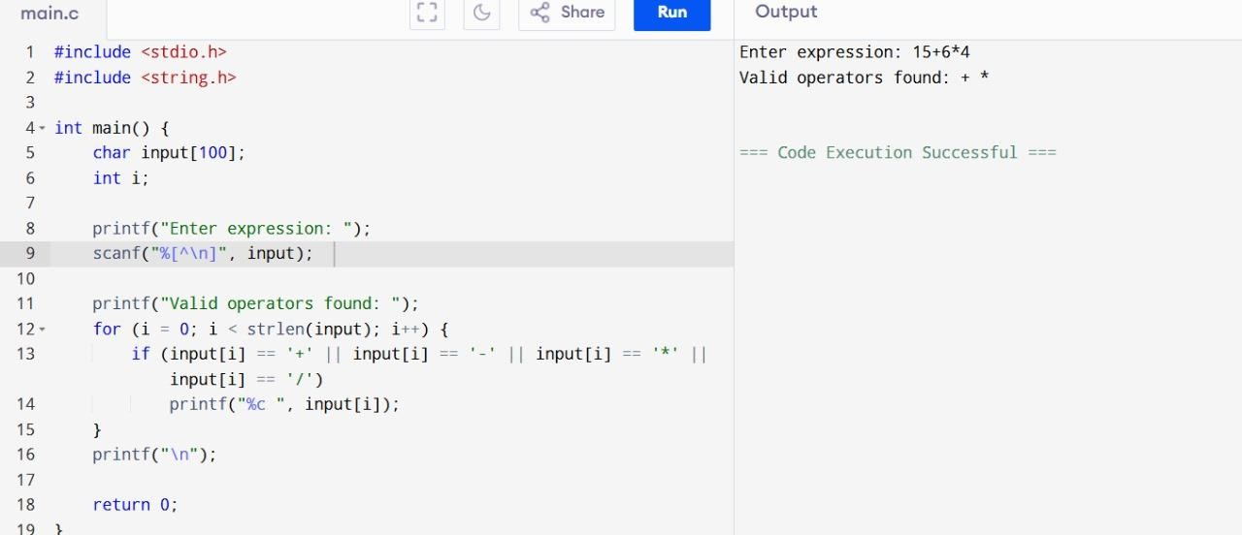

**2. DESIGN A LEXICAL ANALYZER TO FIND THE NUMBER OF WHITESPACES AND NEWLINE CHARACTERS.**

**C PROGRAMMING CODE:**

#include <stdio.h> int main() { char ch; int spaces = 0, newlines = 0;

printf("Enter text (end input with #):\n"); while ((ch = getchar()) != '#') { if (ch == ' ') spaces++; else if (ch == '\n') newlines++;

}

printf("\nNumber of whitespaces: %d\n", spaces);

printf("Number of newlines: %d\n", newlines); return 0;

}

**OUTPUT:**

